

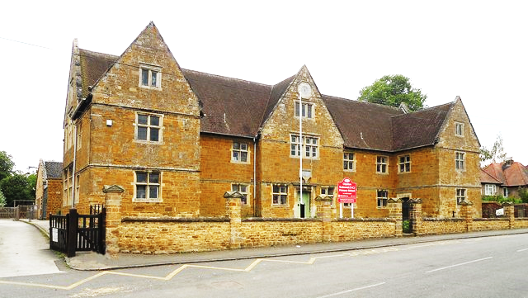

“Be Kind -Be Your Best- Be Happy”
Job Vacancy Clipston Endowed VC Primary School
Teaching Assistant SEN to start as soon as possible
Fixed Term Contract- No Specified End
Our School
Clipston is a small, rural, Church of England primary school with a superb team of friendly, welcoming and happy staff who gel very well together. Governors are supportive and friendly, whilst maintaining a realistic level of challenge. We all work hard and the children are at the heart of everything we do. Our staff room at break and lunchtimes is a friendly place to be; we have time to offload and there us also lots of laughter! If you’d like to join a team of hard working staff, Clipston is the school for you!
The Job Role:
We are looking for a kind, patient, resilient and motivated person to support the learning and development of a child with an ECHP. The successful candidate will need to build a secure, firm but fair attachment with the child in order to support their learning and social development in school as they continue to make progress with communication skills, phonics, early Maths and early Literacy skills.
Visits to the school are warmly welcomed and encouraged. Please arrange a convenient time by contacting the school office: 01858 525261 or via office@clipston.northants.sch.uk
This Fixed Term (non-specified post) is for 31 hours and 15 minutes, 38 weeks per year and the hours are 8.45am – 3.30pm with 30 minutes of breaks each day.
Salary: This is a part-time post and salaries will be paid pro-rata. Depending on experience and qualifications: Grade D Point 3: £25,614
You will receive guidance and support from our SENDCo as well as from the Class Teacher and Class TA, to enable you to adapt planning to suit the needs of the child.
Closing date: Wednesday 25th November 2026
Interviews will take place week beginning 30th November 2026
Please email Mrs Helen Rhodes (Bursar) bursar@clipston.northants-ecl.gov.uk for an application pack and further information or visit the vacancies section on our website

The Governors and staff at Clipston Endowed VC Primary School are committed to safeguarding and promoting the welfare of children and they expect all staff, volunteers and visitors to share this commitment. The post is subject to safer recruitment practices and all necessary checks will be made prior to employment commencing.

